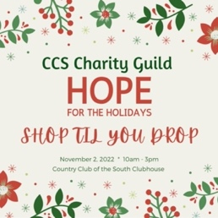
Country Club of the South (CCS) Charity Guild
HOPE for the Holidays
SHOP TIL YOU DROP
November 2, 2022 * 10 am – 3 pm

VENDOR INFORMATION & APPLICATION

Event Details | Location: Country Club of the South Clubhouse Ballroom (4100 Old Alabama Road)  Date: November 2, 2022  Hours: 10am-3pm
Set Up & Take Down | Set up 8 am -10 am. No set up after doors open at 10 am.  Take down 3 pm-5 pm. No take down before 3 pm.
Vendor Fee: $200 | Includes: | One (1) 6’ table, two (2) chairs,  Access to electricity (MUST bring own extension cord)  Access to wifi  Two (2) Admissions for staff to work at table  Web-link to your website on www.CharityGuild.org from 10/01/22 to  12/31/22 (paid vendors only)
Raffle donation | All vendors must donate an item valued at least $25 for the show raffle. The item must be representative of the work sold in your booth.
Payment Deadline | All vendor payments must be received by October 1, 2022
Refund Policy | Cancellations are not permitted after October 1, 2022.
Reserve Today!! | Submit Your Application Today! Table space is available on a first come, first served basis. We anticipate that tables will sell out before the October 1 deadline.
Payment Methods | ​Credit Card: Visit www.CharityGuild.org (click on “More” in upper right corner and select “Hope for the Holidays Booth Fee”)  Check: Payable to CCS Charity Guild. Mail to: Tracy Hobbs, 140 Travertine Trail, Johns Creek, GA 30022  Your Booth will be confirmed when BOTH Payment and Application has been received.
More Info or Questions | Events@charityguild.org
VENDOR APPLICATION – COMPLETE & EMAIL TO Events@charityguild.org
Company Name
Contact Name
Contact Email
Contact Cell #
Website
Product Description
Vendor Signature: |  | Date:

